

**INCREDIBLE INDIA TOURISTWEBPAGE**

AS A PROJECT WORK FOR THE COURSE

**INTERNET PROGRAMING LABORATORY (CSE 326)**

**NAME:SARVESH P SUBMITTED TO:DIVYA THAKUR**

**REGISTRATION NUMBER: 12203515 DATE OF SUBMISSION:01/12/22**

**ROLL NUMBER: RK22GB08**

**SEMESTER:** FIRST SEMESTER

**SCHOOL OF COMPUTER SCIENCE AND ENGINEERING**

**LOVELY PROFESSIONAL UNIVERSITY, JALANDHAR, PUNJAB, INDIA.**

**DECLARATION**

I hereby **SARVESH.P** Regd No.**12203515** declare that the project work reported entitled "**INDIAN TOURISM**” in partial fulfilment of the requirement for the award of Degree for Bachelors of Technology in CSE at Lovely Professional University, Phagwara, Punjab is an authentic work carried out under supervision of my supervisor Ms. **DIVYA THAKUR** . The content of this project represents authentic and honest effort conducted, in its entirety, by me. I am fully responsible for the contents of my project work.

Student Name: SARVESH P Student Signature

Rregistration Number: 12203515

**INDEX**

* 1. **Introduction**
  2. **Tags/Functions**
  3. **Project**
  4. **Code**
  5. **Result**

**HTML ,CSS**

* 1. **INTRODUCTION:**

**HTML:** The HyperText Markup Language or HTML is the standard markup language for documents designed to be displayed in a web browser. It can be assisted by technologies such as Cascading Style Sheets and scripting languages such as JavaScript.

**CSS:** Cascading Style Sheets is a style sheet language used for describing the presentation of a document written in a markup language such as HTML or XML. CSS is a cornerstone technology of the World Wide Web, alongside HTML and JavaScript.

**1.2 TAGS/FUNCTION:**

**HTMLTAGS USED:**

Link,Header,Nav,Class,Div,Href,Section,Style,Target,Title,Html,Head

**CSS TAGS USED:**

Header,Nav,Main,Section,Btnone,ChangeContent,Changetext,

Margin,Padding,Box-Sizing,Font-Family,Width,Height,

Background Image,Background Repeat,Background Size,

Colour,Display,Text-Transform,Text-Align,Justify-Content,

Font-Weight,Align-Items,Textalign,Letter,Spacing,Text-Shawdow,FontSize,FontWeight,Text-Transform,Word-Spacing,Margin-Bottom,Padding,Border Radius,

Outline,LetterSpacing,Text Decoration,Letter Spacing,

Transition,Content

**1.3 PROJECT :**

We have developed a webpage named “Incridable India”,

With the help of Html&Css. This webpage help Foreign People

To know about the tourist places in Indian.Which they can visit when they come here for vacation.

**1.4 CODE:**

**HTML CODE:**

<!DOCTYPE html>

<html>

<head>

    <title></title>

    <link rel="stylesheet" type="text/css" href="css/style.css">

    <link href="https://fonts.googleapis.com/css?family=Josefin+Sans&display=swap" rel="stylesheet">

      <link rel="stylesheet" href="https://cdnjs.cloudflare.com/ajax/libs/animate.css/3.7.2/animate.min.css">

</head>

<body>

<header>

<nav>

    <div class="logo"> <h1 style="font-size: 20px;"> INCREDABLE INDIA </h1> </div>

    <div class="menu">

        <a href="#" style="font-size: ">Home</a>

        <a href="C:\Users\psarv\Desktop\html Project\Untitled-1.html">gallery</a>

        <a href="https://www.incredibleindia.org/content/incredible-india-v2/en.html" target="_blank">about</a>

        <a href="https://www.linkedin.com/in/ritesh-ranjan-"target="_blank">ADMIN SUPPORT</a>

        <a href="http://www.linkedin.com/in/sarvesh-p-"target="blanl">QUERIES</a>

        <a href="">contact-7541065954</a>

    </div>

</nav>

    <main>

        <section>

            <h3>Welcome To India</h3>

            <h1>DO COME & VISIT <span class="change_content"> </span> <span style="margin-top: -10px;"> | </span> </h1>

            <p>"India once is not enough"</p>

            <a href="#" class="btnone">learn more</a>

            <a href="#" class="btntwo">signup here</a>

        </section>

    </main>

</header>

</body>

</html>

**CSS CODE:**

* {

  margin: 0;

  padding: 0;

  box-sizing: border-box;

  font-family: "Josefin Sans", sans-serif;

}

header {

  width: 100%;

  height: 100vh;

  background-image: linear-gradient(rgba(0, 0, 0, 0.3), rgba(0, 0, 0, 0.15)),

    url("../images/PUNJAB.jpg");

  background-repeat: repeat;

  background-size: cover;

}

nav {

  width: 100%;

  height: 15vh;

  background: rgba(0, 0, 0, 0.2);

  color: white;

  display: flex;

  justify-content: space-between;

  align-items: center;

  text-transform: uppercase;

}

nav .logo {

  width: 25%;

  text-align: center;

  /*background: red;*/

}

nav .menu {

  width: 40%;

  display: flex;

  justify-content: space-around;

}

nav .menu a {

  width: 25%;

  text-decoration: none;

  color: white;

  font-weight: bold;

}

nav .menu a:first-child {

  color: #00b894;

}

main {

  width: 100%;

  height: 85vh;

  display: flex;

  justify-content: center;

  align-items: center;

  text-align: center;

  color: white;

}

section h3 {

  font-size: 35px;

  font-weight: 200;

  letter-spacing: 3px;

  text-shadow: 1px 1px 2px black;

}

section h1 {

  margin: 30px 0 20px 0;

  font-size: 55px;

  font-weight: 700;

  text-shadow: 2px 1px 5px black;

  text-transform: uppercase;

}

section p {

  font-size: 25px;

  word-spacing: 2px;

  margin-bottom: 25px;

  text-shadow: 1px 1px 1px black;

}

section a {

  padding: 12px 30px;

  border-radius: 4px;

  outline: none;

  text-transform: uppercase;

  font-size: 13px;

  font-weight: 500;

  text-decoration: none;

  letter-spacing: 1px;

  transition: all 0.5s ease;

}

section .btnone {

  /*background: #00b894;*/

  background: #fff;

  color: #000;

}

.btnone:hover {

  background: #00b894;

  color: white;

}

section .btntwo {

  background: #00b894;

  color: white;

}

.btntwo:hover {

  background: #fff;

  color: #000;

}

.change_content:after {

  content: "";

  animation: changetext 10s infinite linear;

  color: #00b894;

}

@keyframes changetext {

  0% {

    content: "Darjeeling";

  }

  10% {

    content: "Agra";

  }

  25% {

    content: "Jaipur";

  }

  40% {

    content: "kerala";

  }

  60% {

    content: "delhi";

  }

  80% {

    content: "Mumbai";

  }

  100%{

    content: "Punjab";

}

**1.5 RESULTS:**

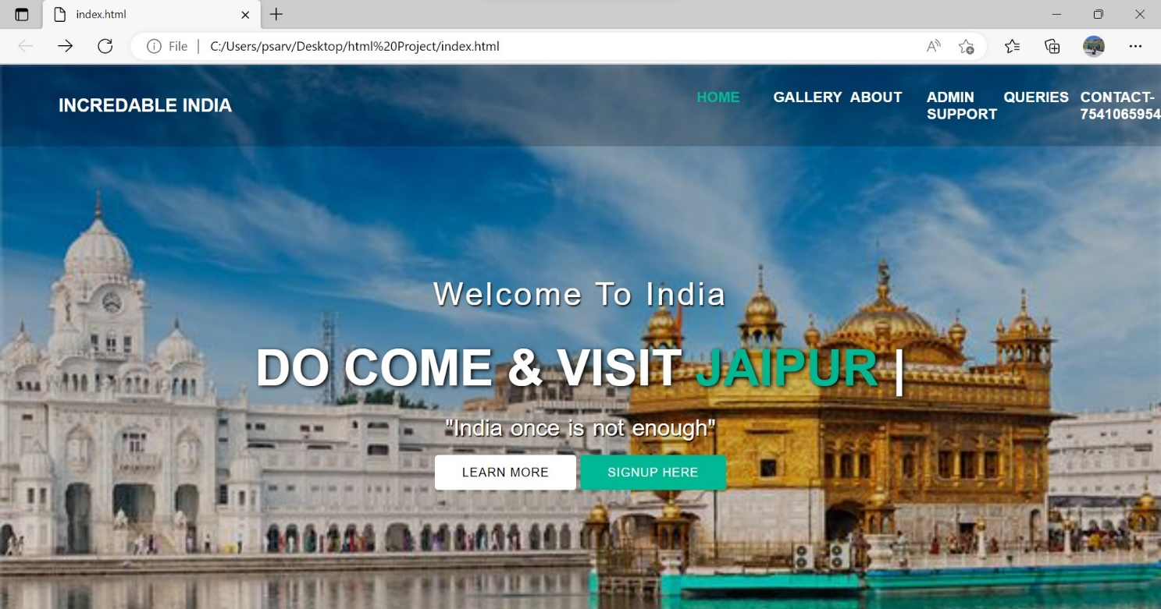

THANKS